KINGDOM MONERA
Answer the following questions:
- Draw a flow chart showing classification of Monera.
- Classify the bacteria on the basis of shapes. Give suitable diagrams.
- Identify the bacteria on the basis of flagellation.
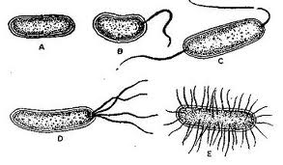
Types
A
B
C
D
E

- Classify the bacteria on the basis of mode of nutrition.
- What do you mean by ‘Archaebacteria’?

