Date:______________
3 Aim : To make a temporary toluidine stained mount of the onion root tip to study various stages of mitosis.
Materials:
Onion root tips, Needles, Brush ,Razor blades, Microscope slides, Coverslips, Microscope, Safety glasses, Gloves, Paper towel, Fixative (1:3 Glacial acetic acid: ethanol), 0.5% toluidine blue, Glycerin
Procedure:
- Obtain an onion bulb that is just beginning to show the emergence of roots. Cut off a root and lay it on a microscope slide. Cut off the first approx 0.5cm of the root tip. Discard the rest of the root. Mitotic cells are in the tip, so extra root tissue will only interfere with finding mitotic cells.
Wear safety glasses and gloves and lab coat.
- Cover the root tip with fixative solution; Let the slide stand for 30 minutes to one hour. After some time of placing the tip in fixative solution you will see some part of root become transparent or translucent. Remove that cleared (transparent) part of the root by cutting it off as that part is the region where cells are elongated (Do not show mitotic cell division).Now you would have a very small piece of root tip which may look pale white or dirty white in color (a dot-sized piece of root tip is all you need).
- Carefully blot around the root to remove excess fixative. Add one drop of fresh toluidine blue stain to the slide let the root tip be stained for 2-3 minutes; after that remove or drain the excess stain (you can even use blotting paper for removing the stain).
- Put one drop of glycerin on the stained root tip and then place cover slip over that. Place the slide between two layers of paper towel on your laboratory bench. Using your finger apply gentle pressure to the cover slip in order to squash and spread the root tip tissue. CAUTION: The applied pressure should be such that it does not break the cover slip.
- Using your microscope (10x), locate the meristematic region of the root tip. Examine the slide at 40x magnification and identify chromosomes at the various stages of mitosis.
- Locate cells in prophase, metaphase, anaphase, telophase, and interphase. Look for evidence of cytokinesis. If the slide is not satisfactory, repeat the procedure.

Stages of Mitosis
Interphase
It is the non-dividing or resting phase of the cell cycle and is a period of nuclear existence between the successive cell divisions.
Comments
Nucleus is large and distinct.
Nucleus with distinct nuclear membrane and nucleolus.
Chromatin network not distinguished into chromosomes.
Prophase
Comments
Nuclear membrane and nucleoli disintegrate and disappear by the end of prophase.
Chromatin material shortens and condenses into thread like structures called chromosomes.
Each chromosome consists of two chromatids jointed at a point called centromere.
Metaphase
Comments
The two chromatids of each chromosome become shorter and thickened to acquire a specific shape and size.
Spindle fibres appear in the cytoplasm between the two centrioles.
Centromere of each chromosome lies on the equator and is attached to the spindle fibres.
Anaphase
Comments
Each centromere divides into two so that each chromatid has got its own centromere.
Spindle fibres get attached to the centromere of their side.
Chromosomes become V or J shaped depending upon the position of the centromere.
Spindle fibres get shortened so that each chromatid with its centromere is pulled apart to its respective pole.
At the poles, each chromatid behaves as an independent chromosome. The chromosomes number of daughter nuclei remains the same as of the parent nucleus.
Telophase

Comments
Chromosomes form the chromatin network.
Nucleolus and nuclear membrane reappear again and two daughter nuclei are formed.
The two daughter nuclei formed are identical to the parent nucleus.
In plant cells, cell plate extends on either side to form middle lamella. It divides the cell cytoplasm into two daughter cells. In animal cells, a cleavage furrow appears in equatorial region and gradually divides to form two daughter cells.

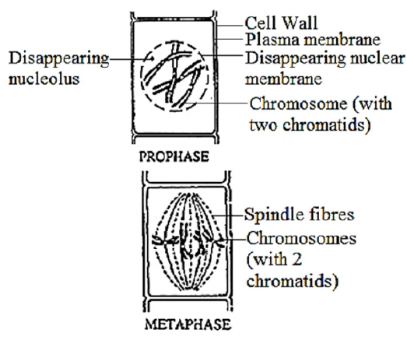

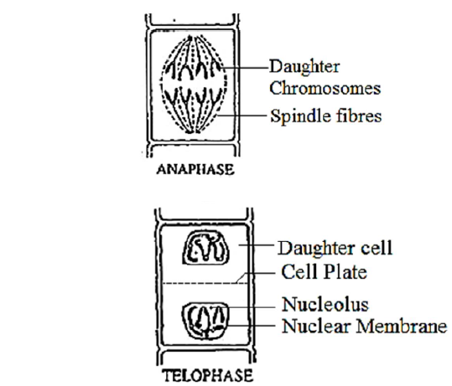
Different stages of mitosis

